Description on how to download Historical EOD data from Ravaonline:

Stock data from the Ravaonline website is available at:
http://www.ravaonline.com./v2/precios/panel.php?m=LID

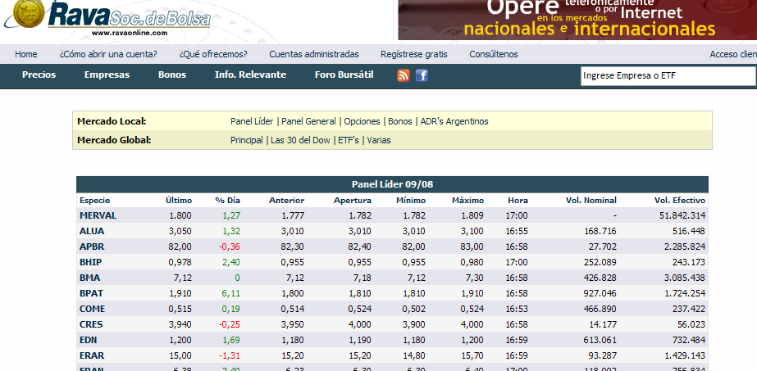

Clicking on each symbol will take you to a web page that you can download historical data in Excel format. For example:
http://www.ravaonline.com/v2/empresas/perfil.php?e=MERVAL

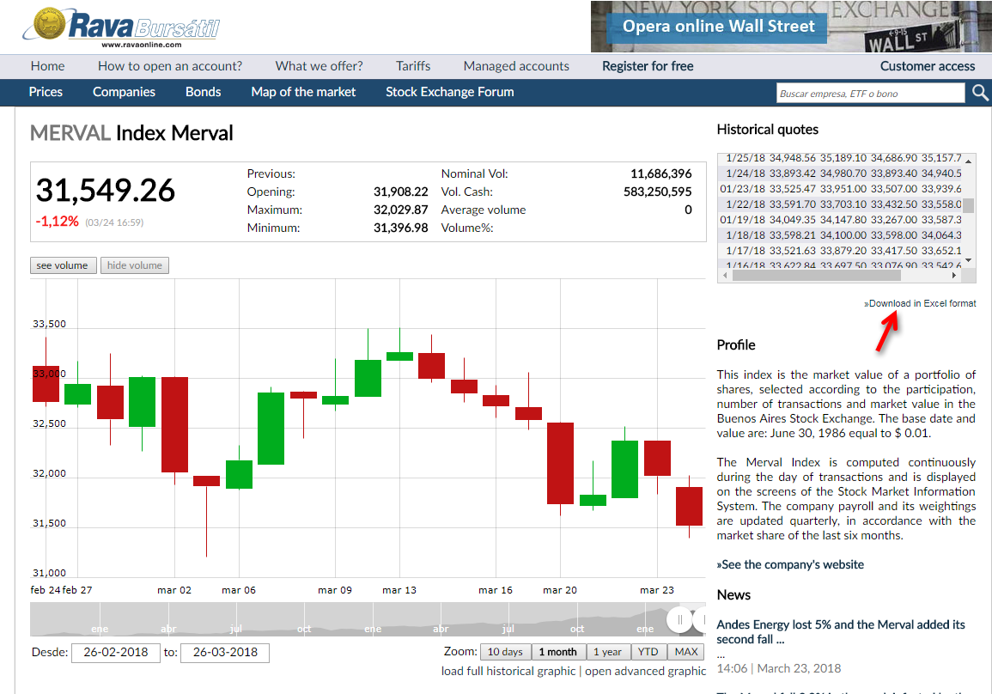

Set-up:

- Copy the following line and append to your existing “mywebserver.txt”, or simply substitute with the attached “mywebserver.txt”.

Ravaonline_D,http://www.ravaonline.com/v2/empresas/precioshistoricos.php?e=SSSS&csv=1,D1,Ravaonline_D1.fmt

- Copy the “Ravaonline_D1.fmt” file to the “fmt” subfolder.
- Run HSQuote Plus and set up “Ravaonline_D1.tic” as shown.

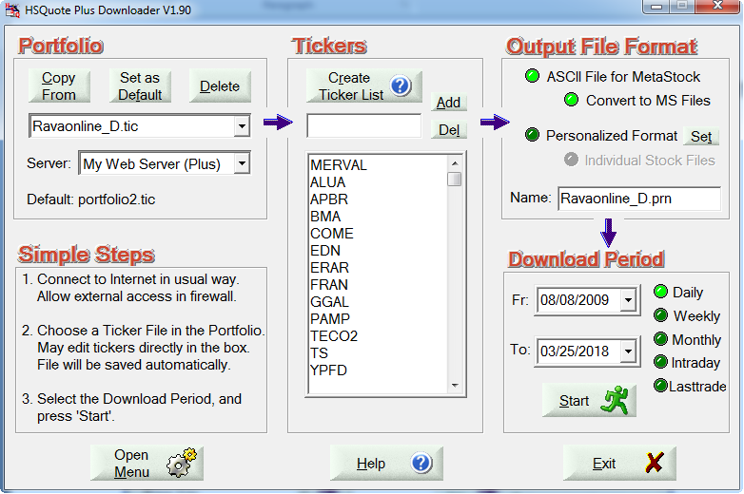

Historical Daily Data Download:

Select the Daily option to download daily data.

